4th Axis Machining

Introduction
In 4th Axis or Rotary machining a part is mounted in a rotary chuck which rotates to allow access to areas of the part not normally reachable by 3 axis machining. In this example we will be finish machining a component which would be difficult to machine using a 3 axis set up due to its length and small inside radii.

- Open a new millimetre milling document.
- Fill in the stock Dimensions form as shown below.

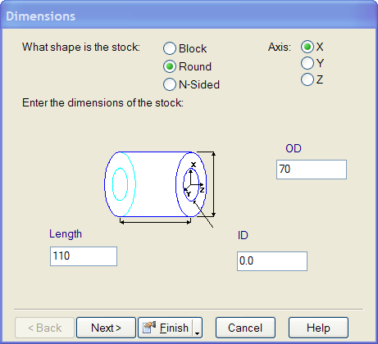

- Press Finish.
- On the Stock properties form select the Indexing tab.
- Fill in the form as shown below.

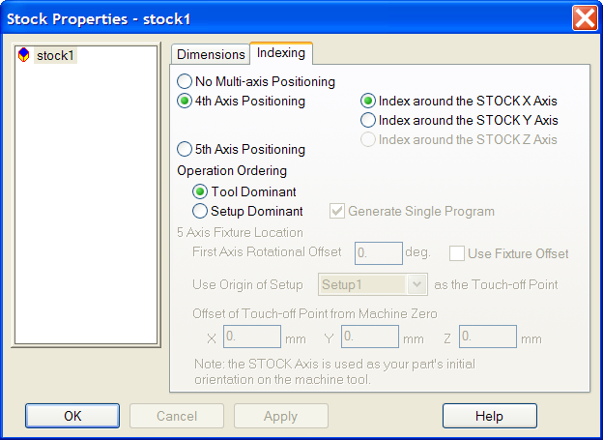

- Press Apply and then OK.
- Import the model Spindle.igs.
- Check Accept the imported data “as is” and exit the wizard.
- Press Finish.
- Select an Isometric view.

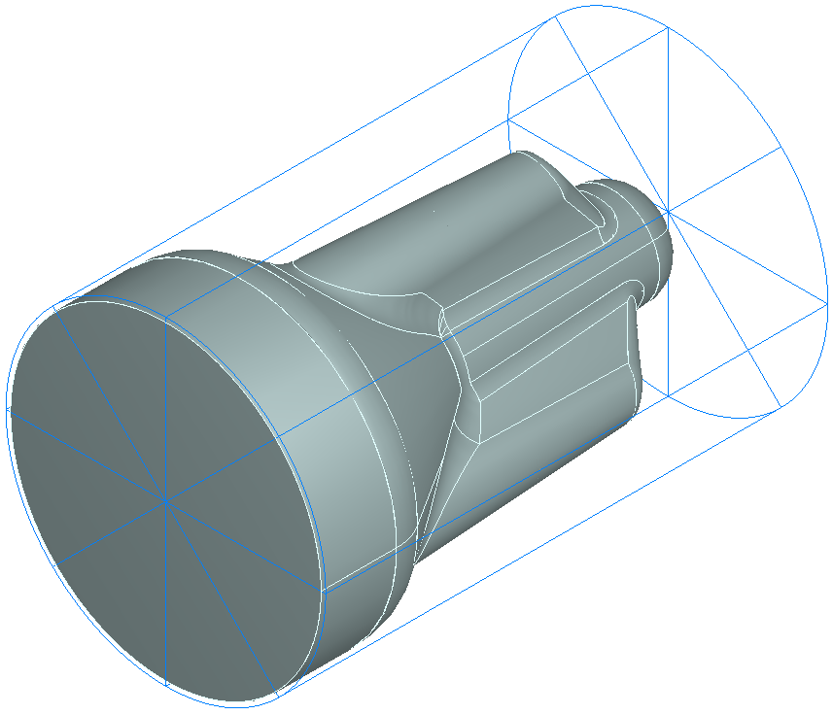

The stock and component are aligned with the X axis. In the stock properties form we told FeatureMILL3D that we were going to use 4th Axis Positioning and were going to rotate around the X axis. We now need to create a surface milling feature.

- Select Features from the Step view.
- Check Surface Milling and press Next.
- Check Choose a single operation and press next.

As you will see there is now a new option on the New strategy form – Four Axis

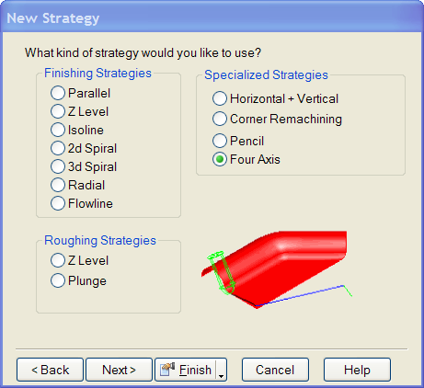

- Check Four Axis and press Next.
- Fill in the form as shown below.

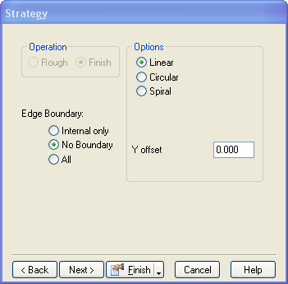

The Y offset allows the tool to be offset away from the default Y zero position. This allows the user to prevent the tool from centre cutting.

- Press Finish.
- Press OK.

- From the main menus select Manufacturing then Post Process.
- Set the Tool change location Z to 100mm.
- Press OK.
- Run a Centreline simulation.

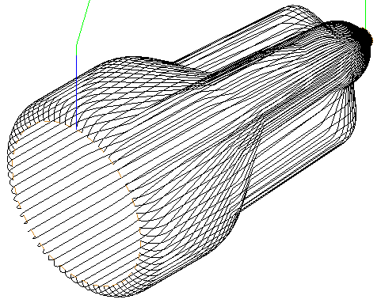

It can be seen that the toolpath is rolling over the ends of the part. We need to limit the extents of the toolpath to give the desired result.

- Edit the feature.
- Click on finish1 in the tree view.
- Select the Milling tab.
- Click on Index start and set the value to 0
- Click on Index end and set the value to 110
- Click Apply and then OK.
- Run a centreline simulation.
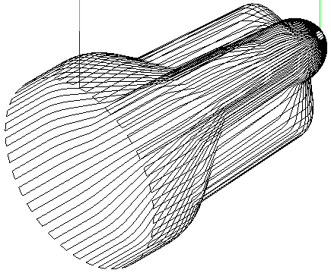

The toolpath is now limited to the portion of the feature between X 0 and X 110. It is also possible to apply an angular limit to the toolpath allowing the user to machine a selected area of the feature.

- Edit the feature.
- Click on finish1 in the tree view.
- Select the Milling tab.
- Click on Angle start and set the value to 0
- Click on Angle end and set the value to 120
- Click Apply and then OK.
- Run a centreline simulation.
- Select a view from the Left.
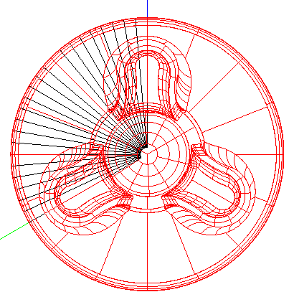

It can be seen that only one third of the part has been machined. The start angle of 0 is aligned with the Z axis, and the end angle of 120 is in the clockwise direction around the X axis.

We will now look at the Circular and Spiral options of 4 axis machining.

- Edit the feature.
- Click on finish1 in the tree view.
- Select the Milling tab.
- Click on Angle start and then Unset.
- Click on Angle end and then Unset.
- Click Apply.
- Click on fouraxis in the tree view.
- Check the Circular option on the Strategy tab.
- Click Apply and then OK.
- Select an Isometric view.
- Move the Simulation speed slider to the left to slow down the simulation.
- Run a centreline simulation.
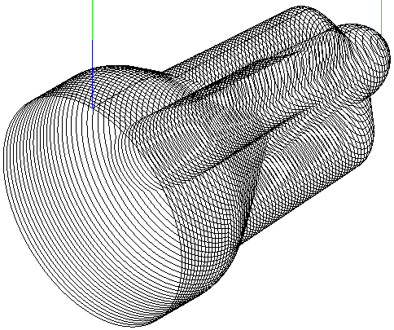

This time the toolpath runs around the part instead of along it. The direction of rotation reverses on each pass. The tool steps over on the surface of the part between passes.

- Edit the feature.
- Click on fouraxis in the tree view.
- Check the Spiral option on the Strategy tab.
- Click Apply and then OK.
- Select an Isometric view.
- Run a centreline simulation.

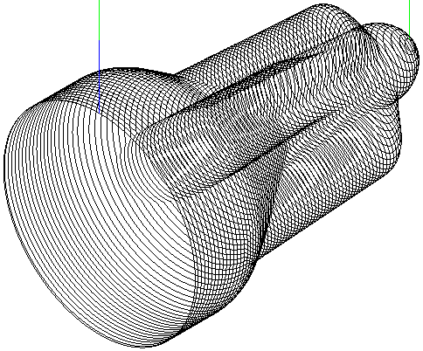

With the spiral option selected the toolpath follows a continuous spiral along the part. This will give a better surface finish than the circular option as there will be no dwell marks from stepover moves. The strategy will require a machine tool with a rotary axis which can rotate continually with no axis limit. We will now look at controlling the cutting direction.

- Edit the feature.
- Click on finish1 in the tree view.
- Select the Milling tab.
- Click on Index start and set the value to 110
- Click on Index end and set the value to 0
- Click Apply and then OK.
- Run a centreline simulation.

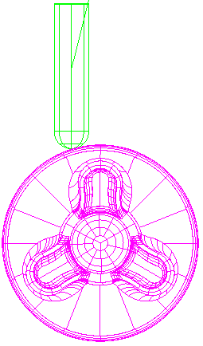
It will be seen that the X direction of cutting has been reversed with the tool starting at X 110 and ending at X 0.

- Edit the feature.
- Click on fouraxis in the tree view.
- Set the Y Offset to be 10mm..
- Click Apply and then OK.
- Select an Isometric view.
- Single step a centreline simulation.

It can be seen that the cutter is now offset from the rotary axis by 10mm in the Y direction. This means that the tool is not centre cutting. This will create better cutting conditions giving improved surface finish and tool life.

